SWECC004 — Chlorophyll analysis
UV-Vis spectrophotometry, 80% acetone extraction (Lichtenthaler & Welburn, 1983)
Natuurbegraafplaats Huis ter Heide, De Moer (Zeist) — seven oaks
Nālani Balcells · Avans University of Applied Sciences · June 2026

1. Purpose and methods
Chlorophyll concentration is the most direct quantitative measure of leaf photosynthetic capacity available in this study, and is treated here as the primary indicator of leaf-level oak vitality. The lab measurement followed Lichtenthaler &amp; Welburn (1983) in 80 % acetone. Briefly: a 10 mm circular punch from a fully expanded sun-exposed leaf was placed into a centrifuge tube containing 3 mL of 80 % v/v acetone, kept in the dark at 4 °C for 24 hours to allow complete pigment dissolution, then centrifuged at 3000 rpm for 5 minutes. Absorbance was read on a UV–Vis spectrophotometer at 645 nm and 663 nm, and the three Lichtenthaler &amp; Welburn pigment equations were applied:
Chl a (μg mL⁻¹) = 12.21 · A₆₆₃ − 2.81 · A₆₄₅ Chl b (μg mL⁻¹) = 20.13 · A₆₄₅ − 5.03 · A₆₆₃ Total Chl (μg mL⁻¹) = 17.76 · A₆₄₅ + 7.43 · A₆₆₃
Twenty-four leaves were measured per tree — three leaves at each of the four cardinal directions (N, E, S, W), with both the adaxial and the abaxial surface sampled — giving 168 measurements over the seven study trees (FT01, FT02 and FT03 Bokashi; NFT04, NFT05 and NFT06 Untreated; HT07 Healthy reference). The unit of statistical analysis is the individual leaf reading for within-tree variability and the tree mean for between-treatment comparison.

2. Group-level results
The treatment-level pattern (Figure 1) follows the expected ordering by visual vitality: the healthy reference tree HT07 has the highest mean total chlorophyll at 13.66 ± 2.12 μg mL⁻¹ (n = 24), the bokashi-treated group is intermediate at 10.61 ± 2.37 μg mL⁻¹ (n = 72), and the untreated group is lowest at 9.80 ± 2.73 μg mL⁻¹ (n = 72). The bokashi mean exceeds the untreated mean by 0.81 μg mL⁻¹ (approximately 8 %), and the healthy-reference mean exceeds the bokashi mean by 3.05 μg mL⁻¹ (approximately 29 %). The within-group spreads overlap substantially, so the treatment effect is in the expected direction but is smaller than the within-treatment biological variability at this site.
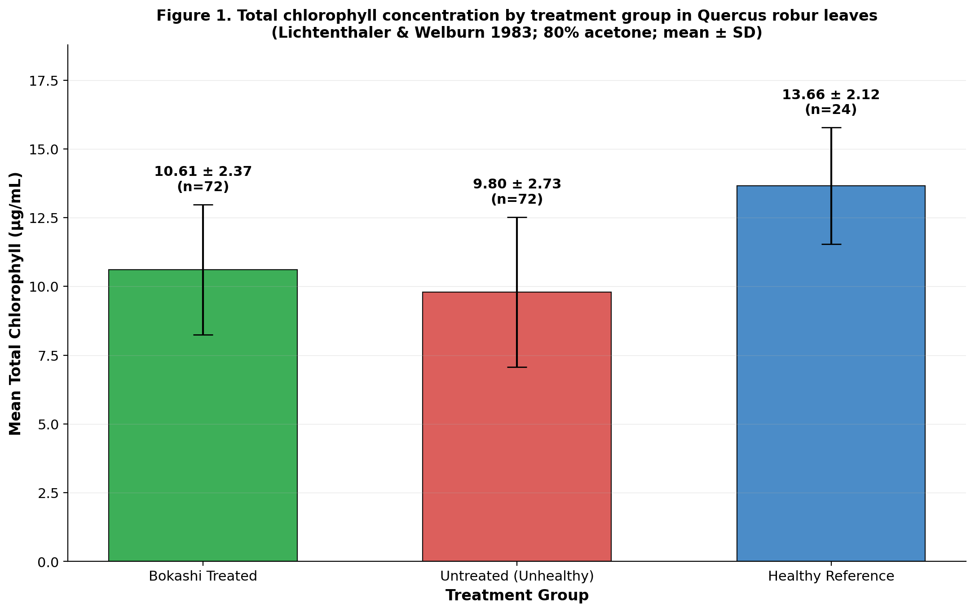
Figure 1. Mean total chlorophyll concentration per treatment group. Bars show the group mean ± SD across all readings; n is the total number of measurements per group.

3. Individual-tree results
The per-tree picture (Figure 2) is essential context for the group means above, because it shows that the treatment groups are internally heterogeneous and that the group means are not representative of every tree. Within the bokashi group, T2 (FT02) has the highest mean chlorophyll at 12.35 μg mL⁻¹ — close to the healthy reference — while T1 (FT01) has the lowest at 8.85 μg mL⁻¹. Within the untreated group, T4 (NFT04) has the second-highest tree mean of any sampled tree at 11.80 μg mL⁻¹ — higher than two of the three bokashi trees — while T5 (NFT05) has the lowest overall at 8.37 μg mL⁻¹. Three implications follow. First, T2 demonstrates that bokashi-treated trees can reach near-healthy chlorophyll levels, supporting the working conclusion that the treatment is moving leaf vitality in the right direction. Second, the within-treatment outliers (T1 low, T4 high) match the soil-physical and visual-crown evidence reported in the Soil analysis and Visual crown assessment folders, where T1 is the bokashi tree with the slowest infiltration and the lowest earthworm density, and T4 is the untreated tree with the worst crown. Third, the spread of values within each tree (24 readings per box) is comparable to the spread between treatment means, which is why the eight-percent group-level bokashi effect should be interpreted as a working signal rather than as definitive evidence of treatment benefit.
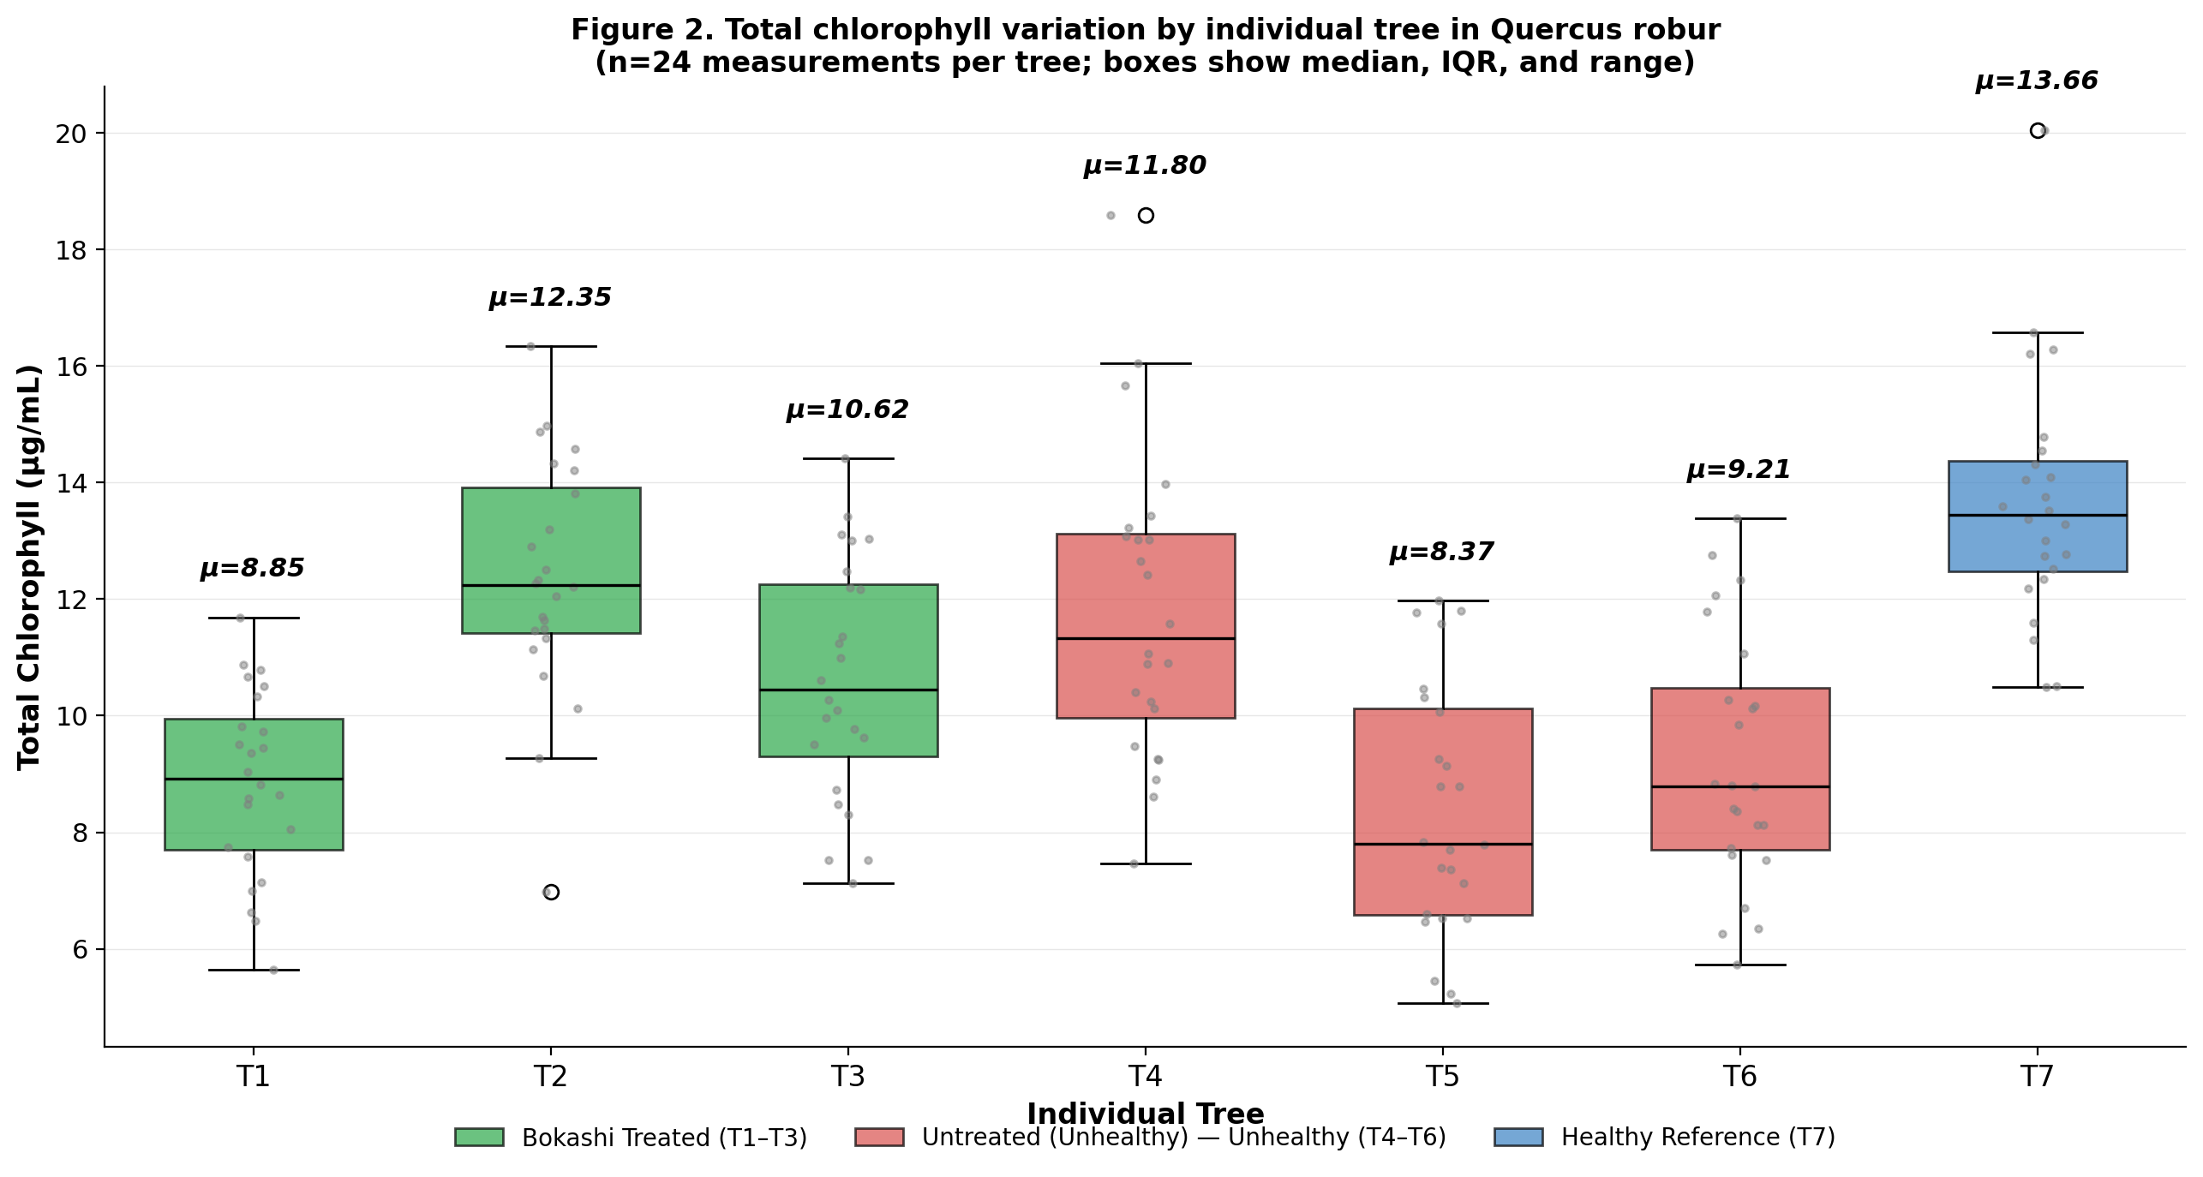
Figure 2. Total chlorophyll variation by individual tree. Boxes show the median and IQR; whiskers extend to 1.5 IQR; the per-tree mean (μ) is printed above each box; grey dots are the individual leaf readings.

4. Conclusions

4.1 Bokashi has a small positive effect on leaf chlorophyll
The bokashi-treated group has measurably higher mean total chlorophyll than the untreated group at this site (10.61 vs 9.80 μg mL⁻¹), in the direction expected if bokashi improves the underlying nutrient supply (particularly phosphate, ammonium and magnesium — reported in the Soil analysis and Leaf nutrient analysis folders). The effect size is small relative to within-group variability and the treated mean remains roughly 22 % below the healthy reference, so the statement is best phrased as bokashi has begun to move leaf chlorophyll in the right direction rather than as bokashi has restored chlorophyll levels.

4.2 Per-tree variation is large and tracks the integrated picture
The two-fold range of tree means within each treatment group (T1 at 8.85 vs T2 at 12.35 in bokashi; T5 at 8.37 vs T4 at 11.80 in untreated) is large and is not random — the same trees that are outliers on chlorophyll are also outliers on the soil-physical, visual-crown and integrated z-score profiles. T1 is the within-bokashi outlier on every soil and crown indicator measured. T4 has the worst crown of any tree despite a relatively high chlorophyll value, which is the strongest reminder in the dataset that chlorophyll is a snapshot of the recently expanded leaf cohort and does not by itself capture cumulative crown damage.

4.3 Implication for monitoring
Chlorophyll measurement remains the single most informative leaf-level vitality indicator in the SWECC004 protocol, and is the lab method against which the smartphone-based PhotoFolia readings were validated (see PhotoFolia analysis folder, Figure 5: per-tree r = +0.95 against UV-Vis chlorophyll). In subsequent monitoring rounds the recommended approach is to use PhotoFolia for the routine 24-readings-per-tree sweep, and to confirm with destructive UV-Vis chlorophyll on a subset of leaves once per season. Total chlorophyll, Chl a and the Chl a : Chl b ratio should all be reported, since shifts in the ratio give an early indication of stress-induced pigment breakdown ahead of changes in total chlorophyll.

Files in this folder
chlorophyll_analysis.R — full reproducible R script that reads spec_meter_readings.xltx, applies the Lichtenthaler &amp; Welburn equations and produces the two figures plus summary CSVs.
spec_meter_readings.xltx — raw UV-Vis absorbance readings (A645 and A663) for the 168 leaf surfaces, with the sample-ID convention T1..T7 / L1–L3 / N|E|S|W / T (Top, adaxial) | B (Bottom, abaxial).
Chlorophyll_Equations_and_Calculations.xlsx — working spreadsheet that documents the Lichtenthaler &amp; Welburn equations, the per-leaf calculation in Excel and a worked numerical example.
chlorophyll_full_data.csv — per-leaf computed Chl a, Chl b and total chlorophyll, with treatment annotation.
summary_by_treatment.csv, summary_by_tree.csv — group and per-tree summary statistics.
chl_fig1_by_treatment.png, chl_fig2_by_tree.png — the two figures reproduced in this document.
SWECC004_chlorophyll_description.docx — this document.

